**Git & Github :**

**(Best Practice : Always first make repository in github and then clone it to local machine in project)**

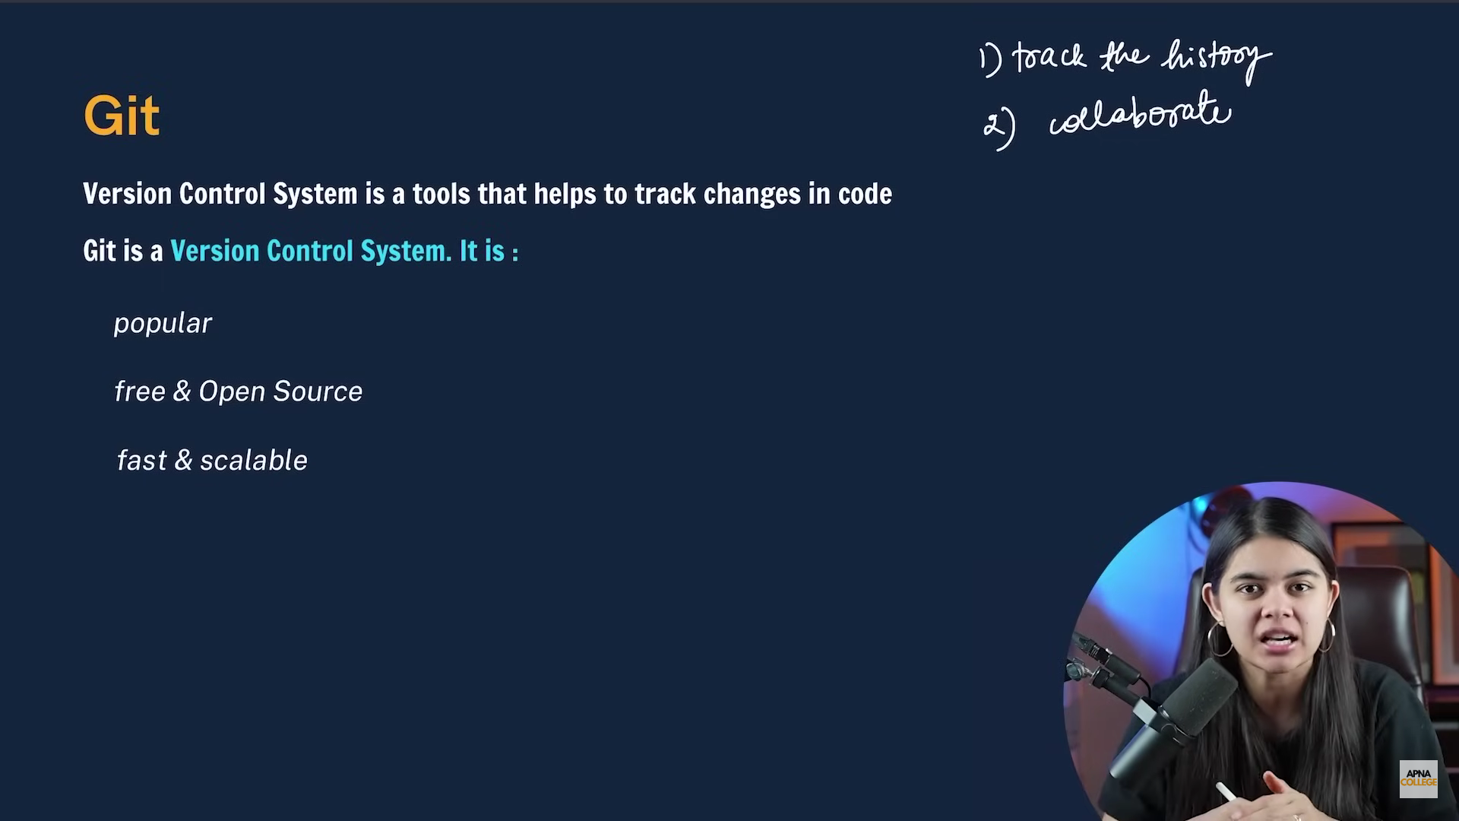

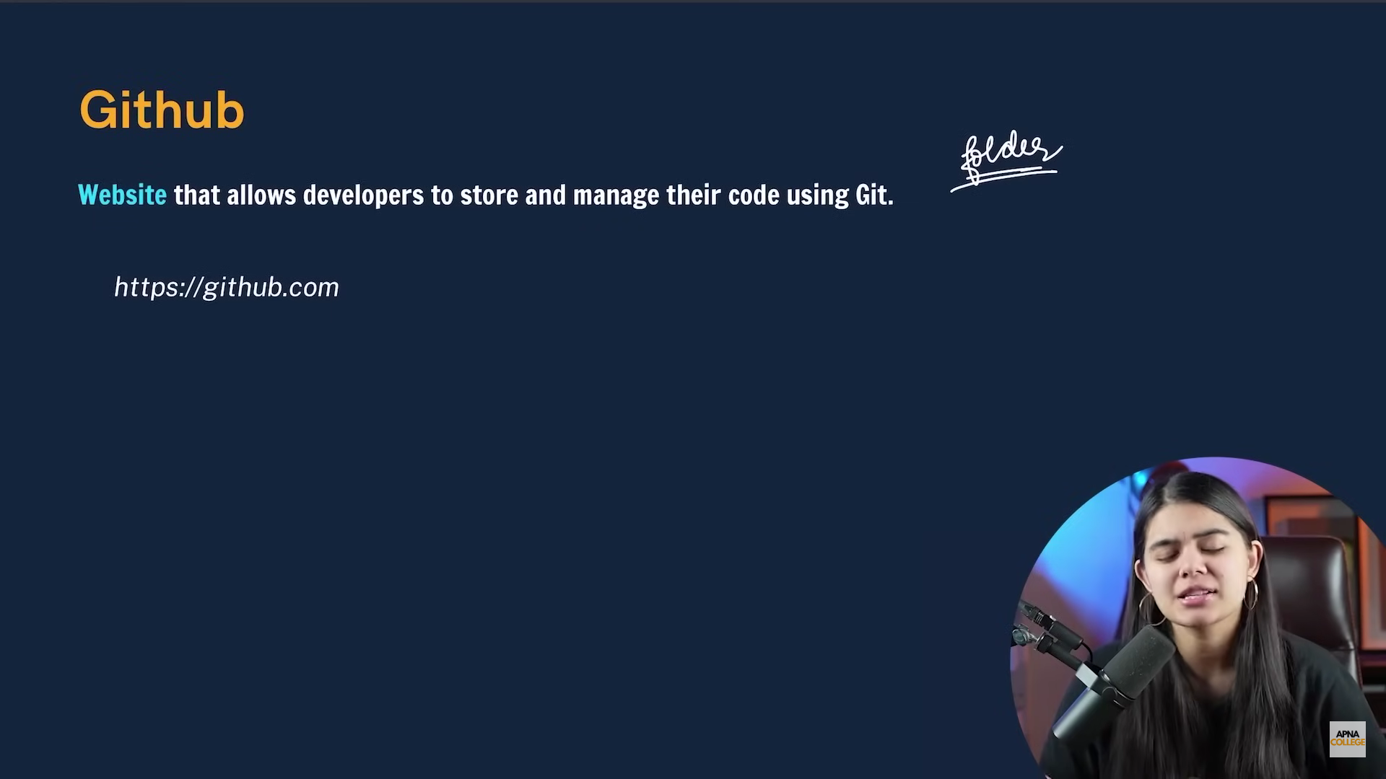

1. **Git Config:**

🡪To check the configurations of git

git config –list

git config –global user.name

git config –global user.email

* To set up the global or local configuration using git

git config –global user.name “Name” (Use git hub name)

git config –global user.email “email” (Use git hub email)

1. Clone and Status

* To download a remote repository from github or any other to local we use clone

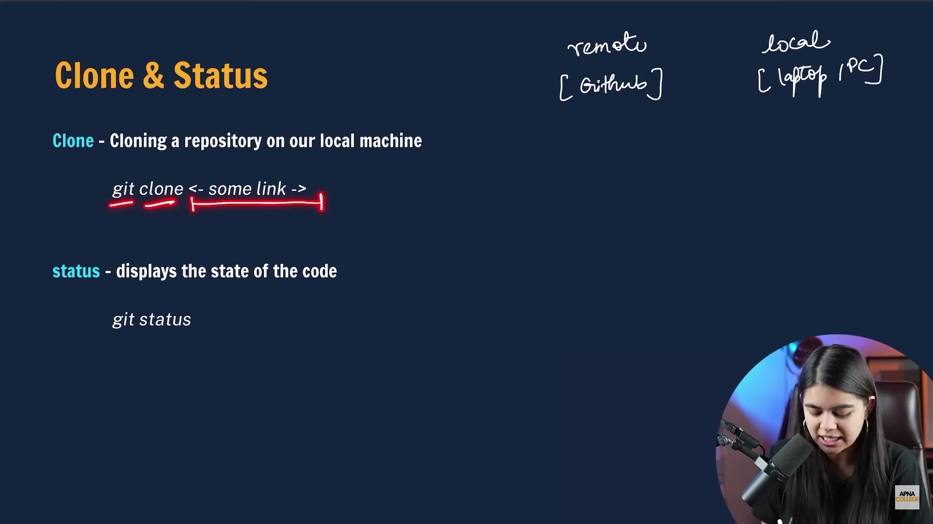

git clone <Link of repository> (It creates new folder to our current directory)

Here after cofig email clone command is fired.

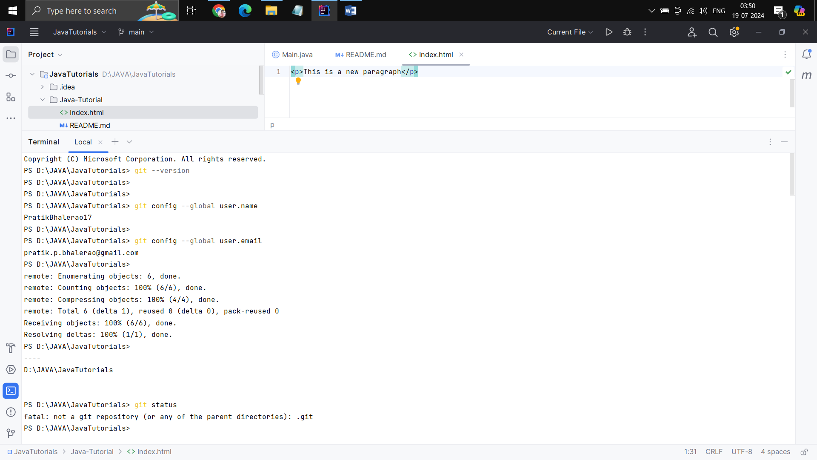

* Status can give the details about changes in the repository i.e. untracked,staged,modified,unmodified

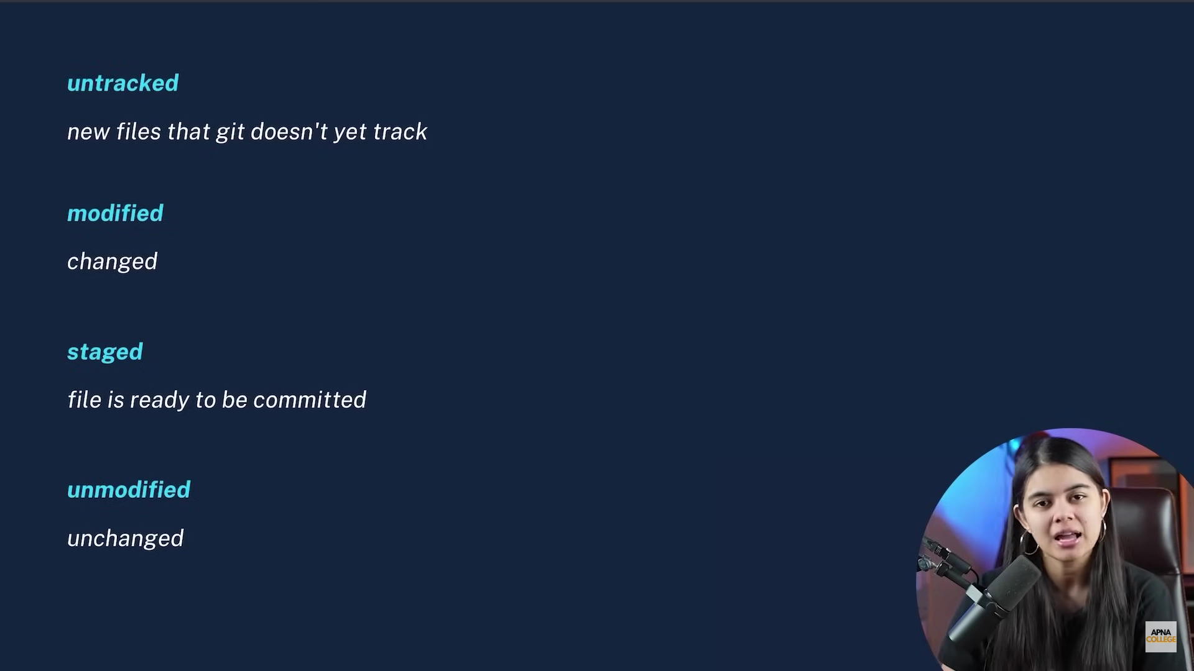

Status command:

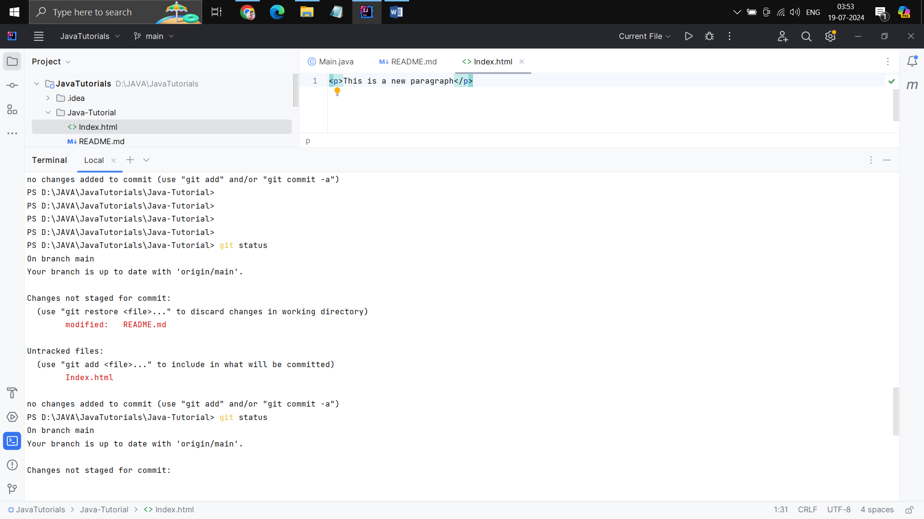

After git is initialized .git folder is created which is hidden & can view with **ls -a** where -a means all.

1. Add & Commit

* Commit is 2 step process,first we add the files to staged area and after that we commit it.

**git add .** or **git add filename** (with . we can add all modified or untracked files)

* After that we can commit the changes using **git commit -m “Commit message”**

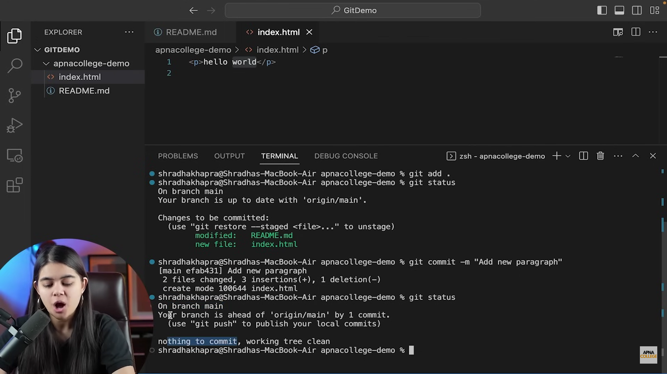

1. Push command:

We used to push our code from local to remote repository(github).

🡪git push origin main (we can also use **git push -u origin main** -u will save the origin location and in future we can just mention **git push** )

(Here origin is name of our repository which we clone or a origin repository and all our push will add data to this repository on remote github & main is a branch in which we need to add the code)

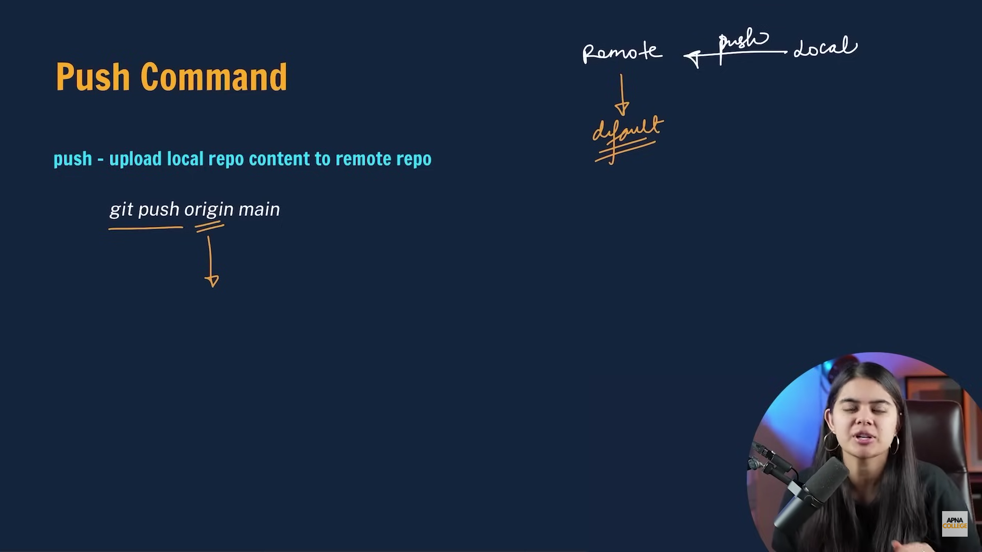

1. Git Init:

We use init command to create a new git repository on local machin. Create a local folder then **git init** afterthat .git folder is created in a local machine.

Then create a repository on github and add origin as that repo using

**git remote add origin <link of repository>** with this our default repository is set as the link we have provided.

To check branch **git branch**

To rename branch **git branch -M name**

After that we can push code to our repository.

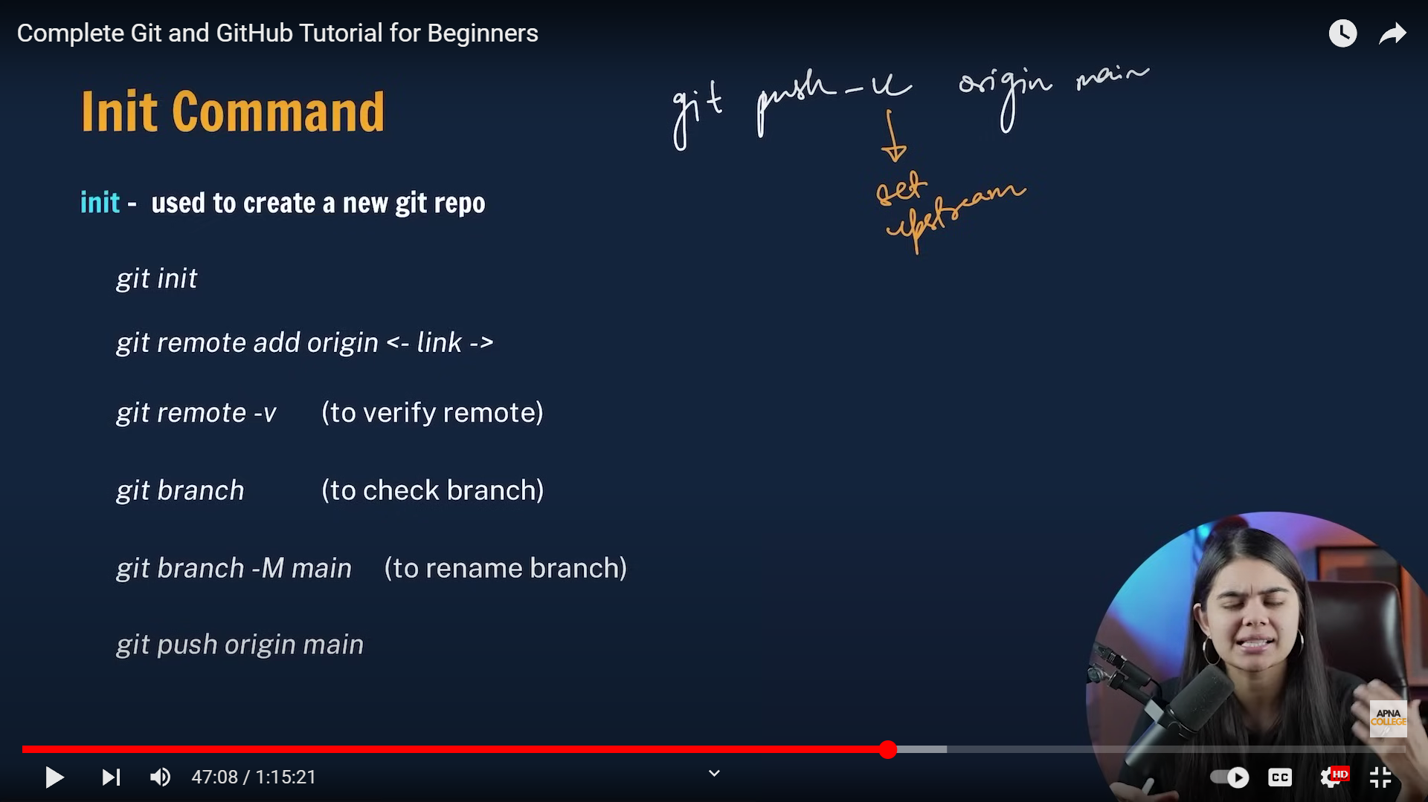

1. Git branch

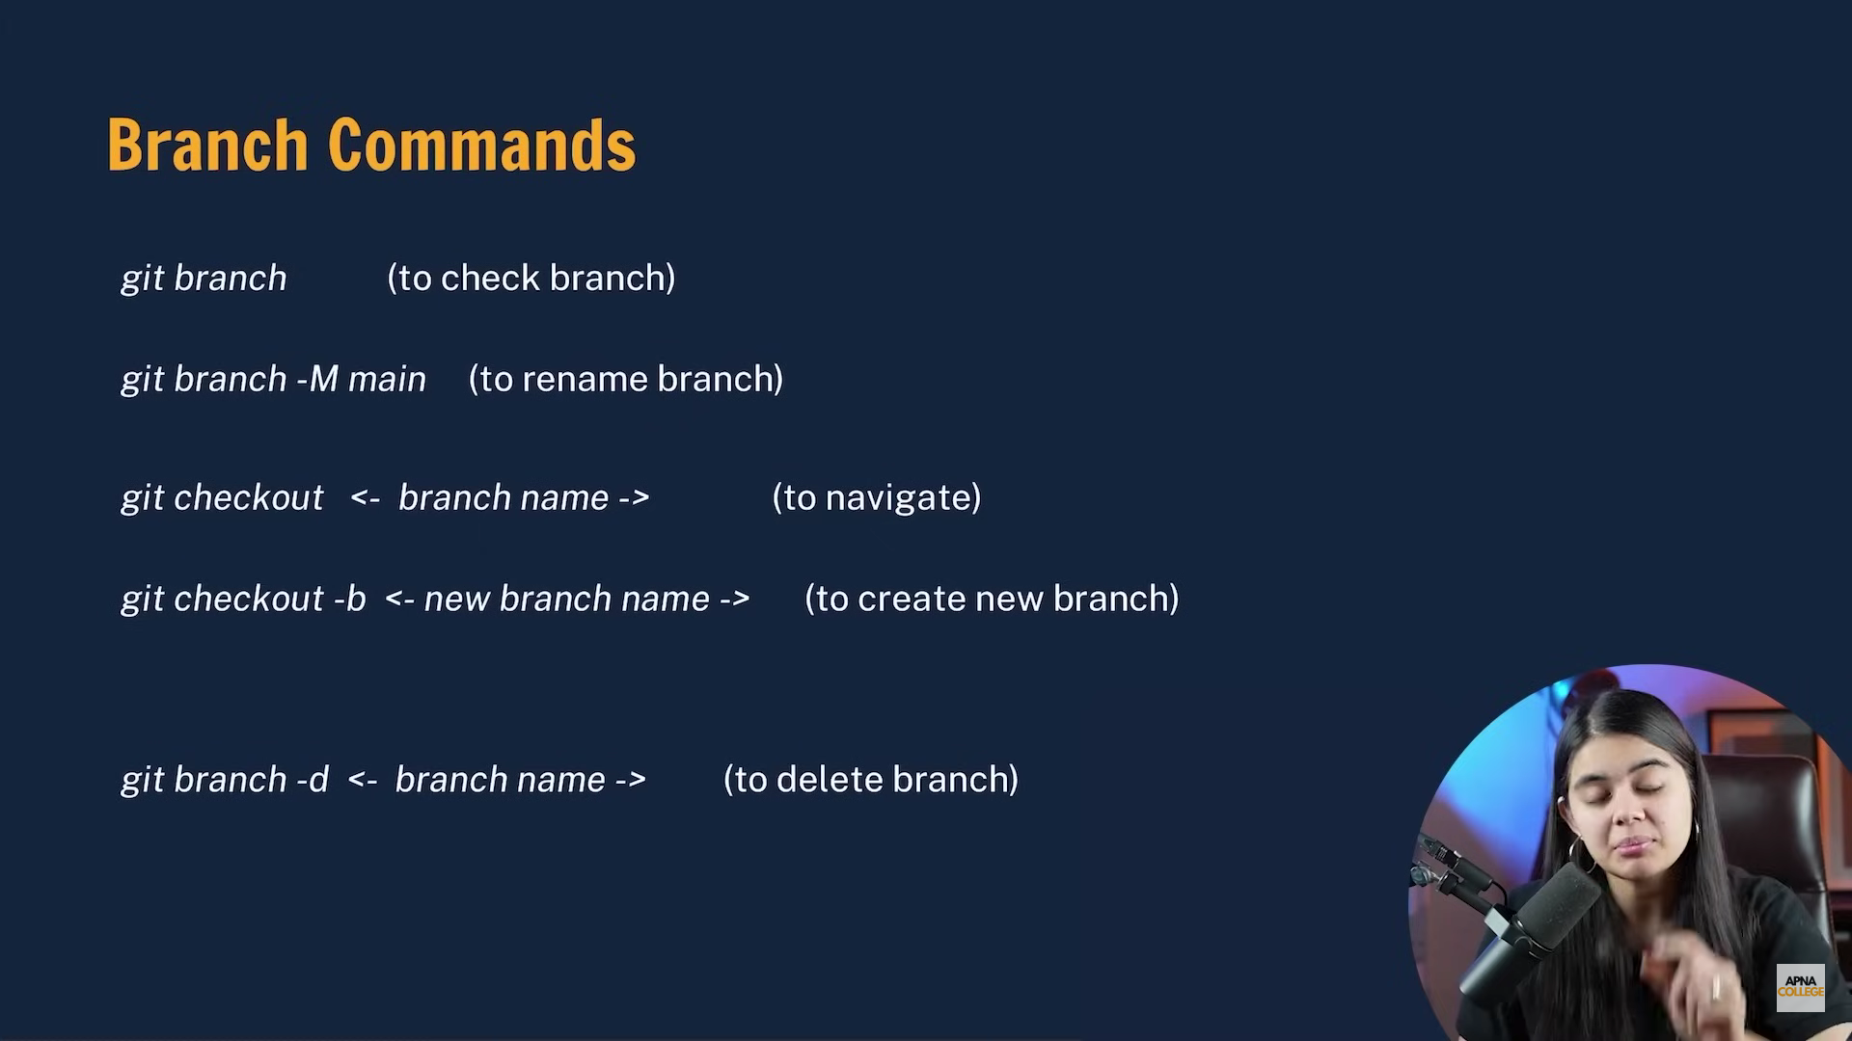

We cannot delete branch on which we are currently

We can push the code to github in new branch as **git push origin feature1** (Here mention only those branch name which we make changes)

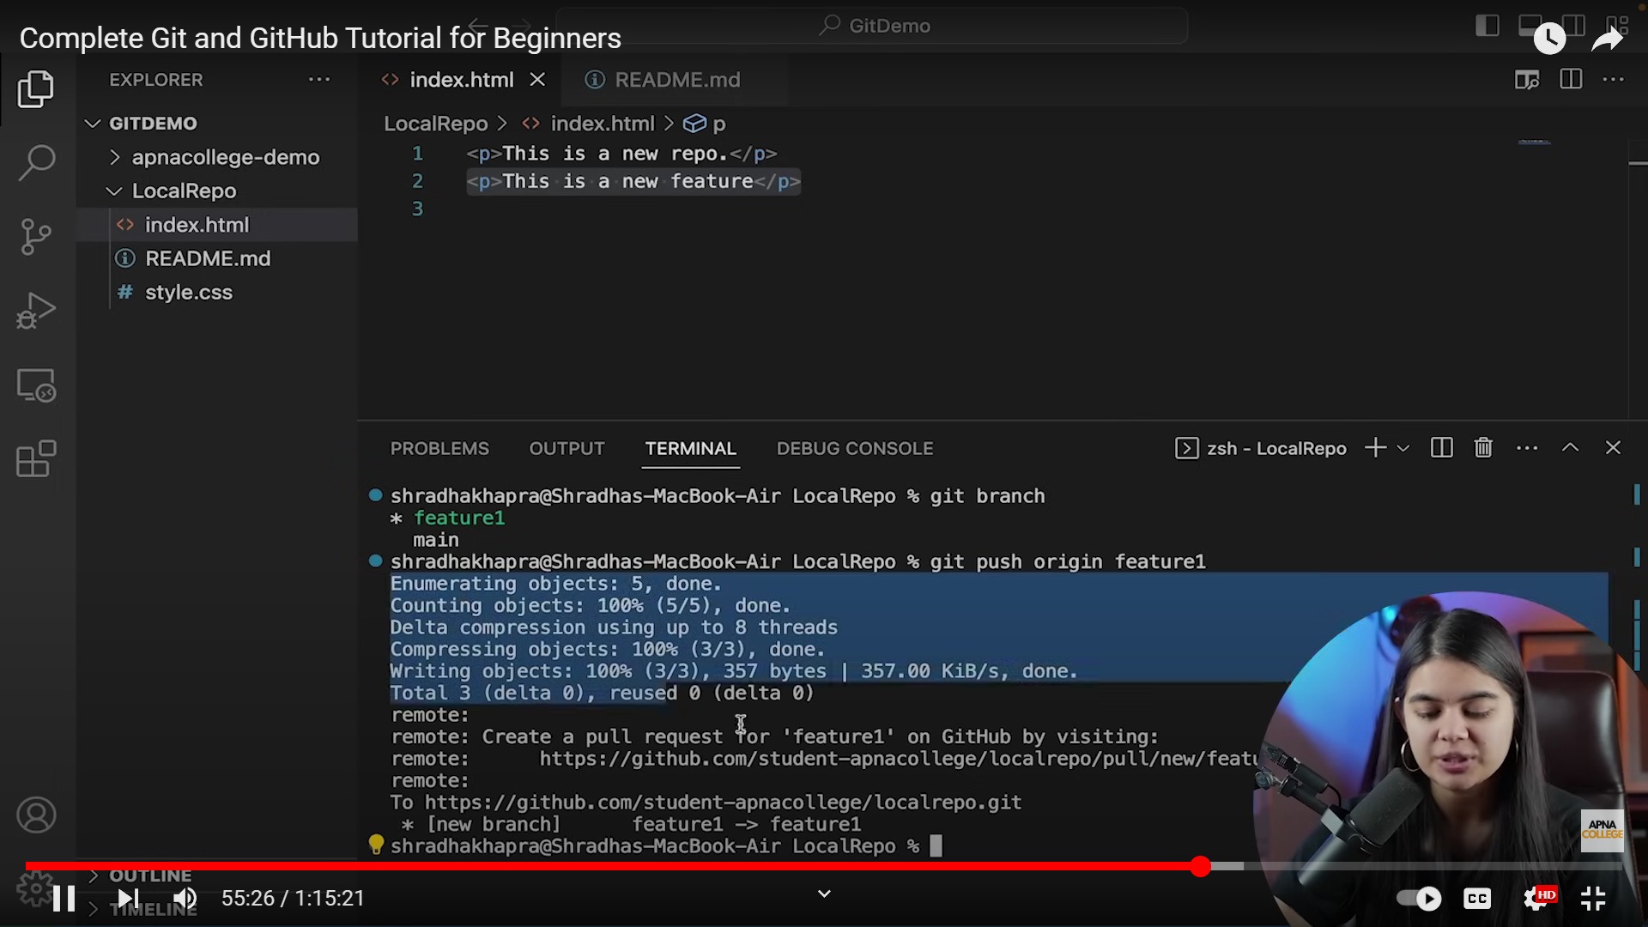

1. Merge Branches

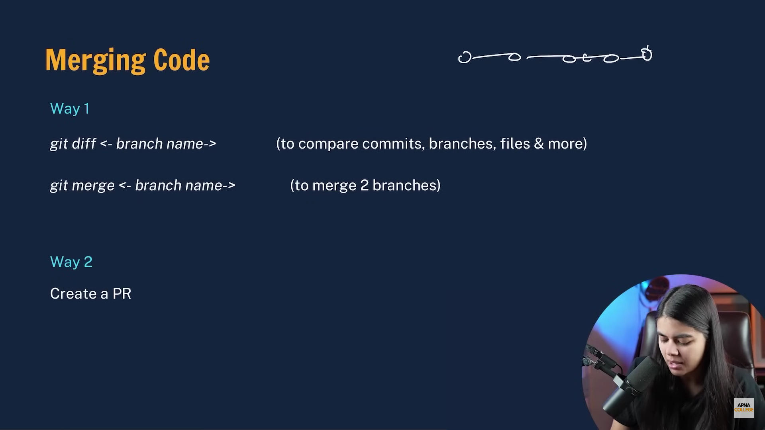

PR(Pull request): With the help of it we can merge our branch to main on github. Once PR request is created a senior developer will review the changes once done then he’ll merge the branches.

1. Git pull:

If we are performing merge using PR the changes are reflected in github but not in our local working directory.

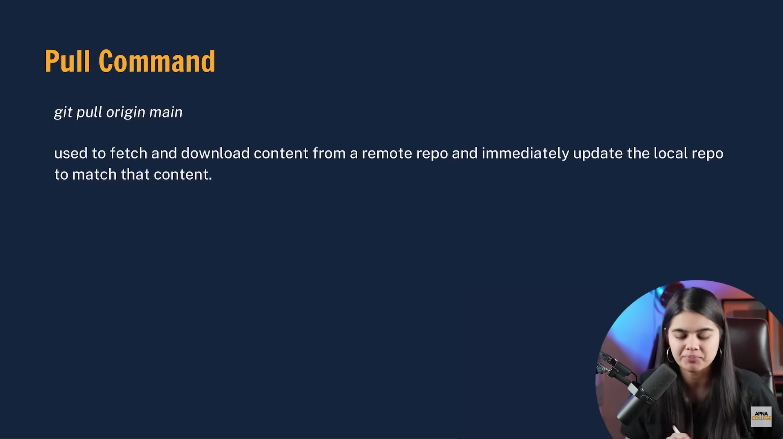

While merging 2 branches if any file has different content on both the branches then it give merge conflict.

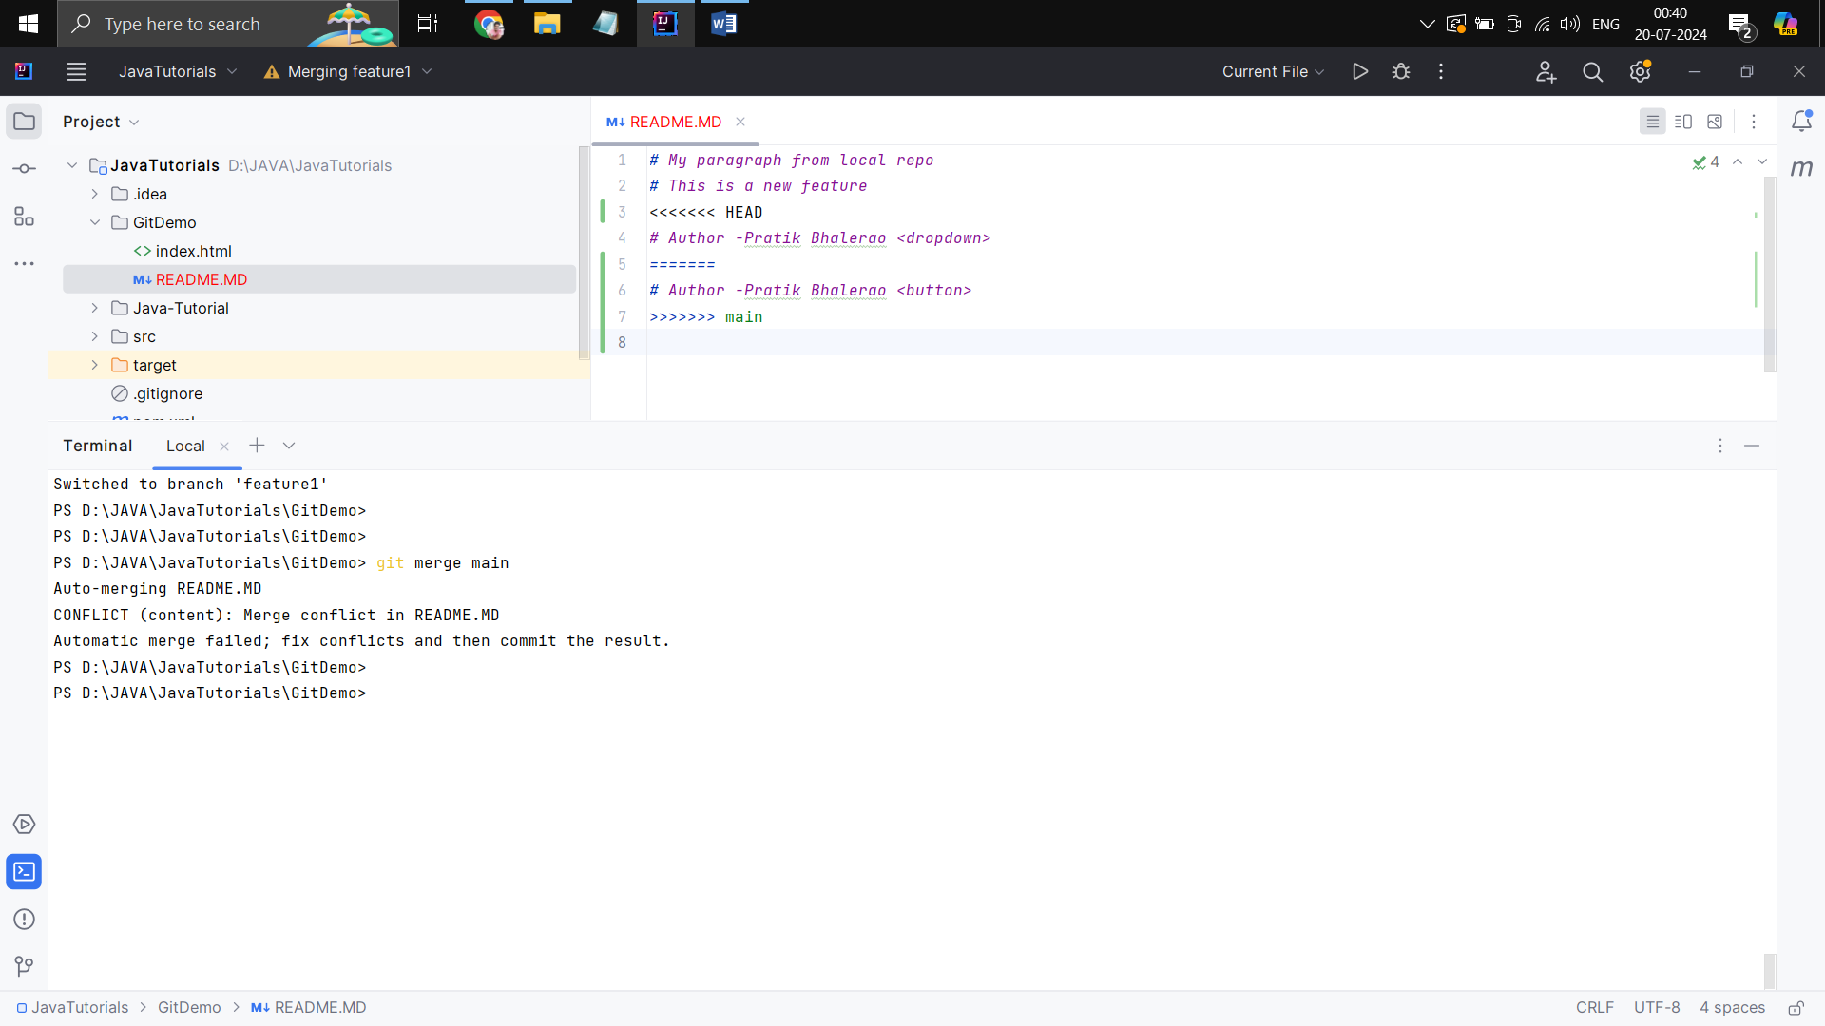

First resolve it and then merge 2 branches

1. To undo changes made in git:

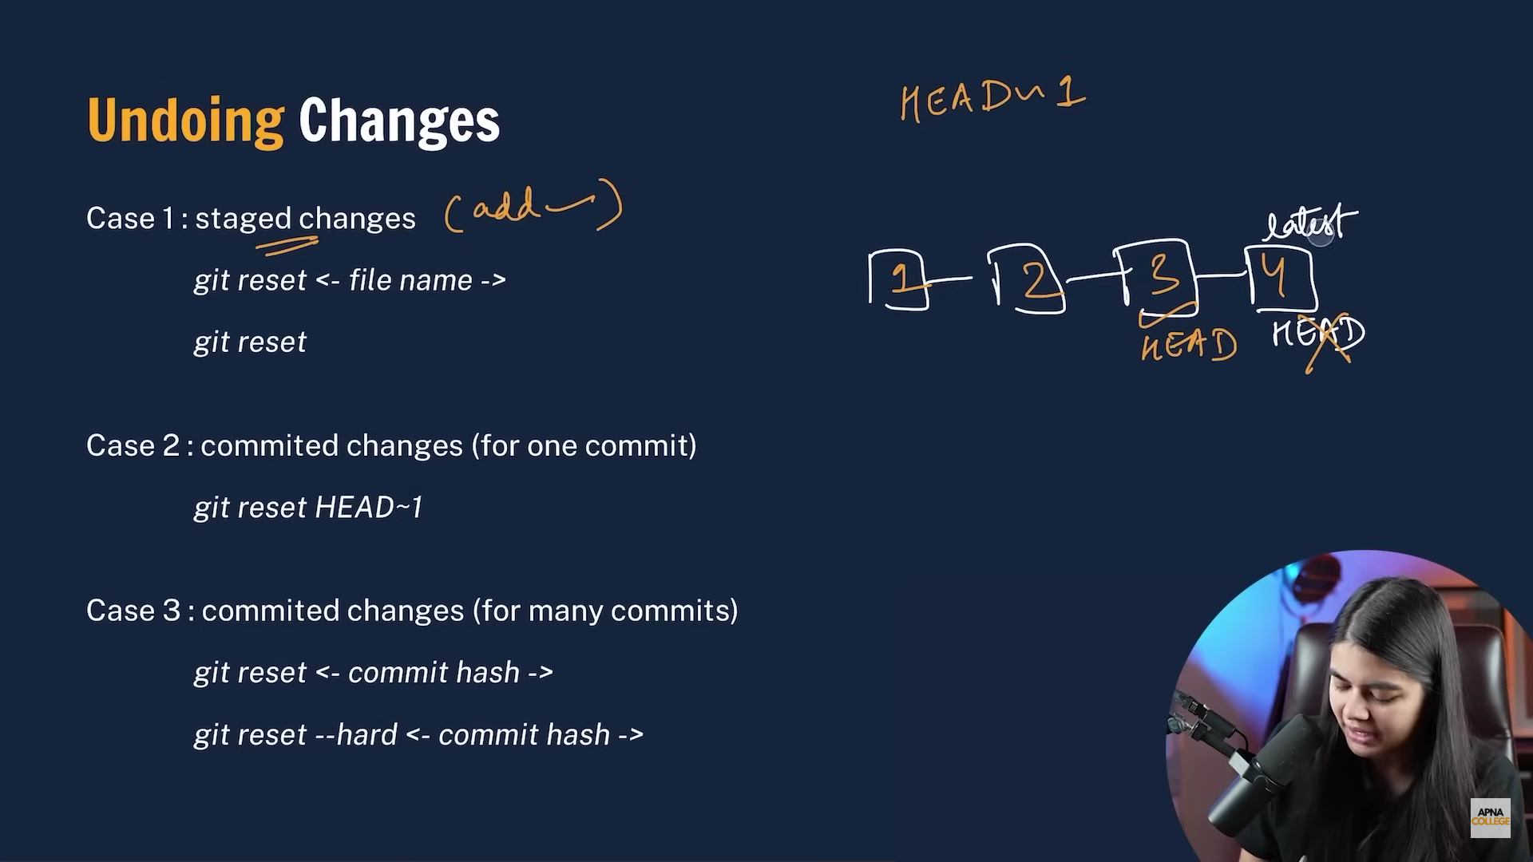

By **git log** we can get commit hash and all commits logs.

**Reset –hard** can also delete the data i.e. modified data after that commit from the files.

1. Fork

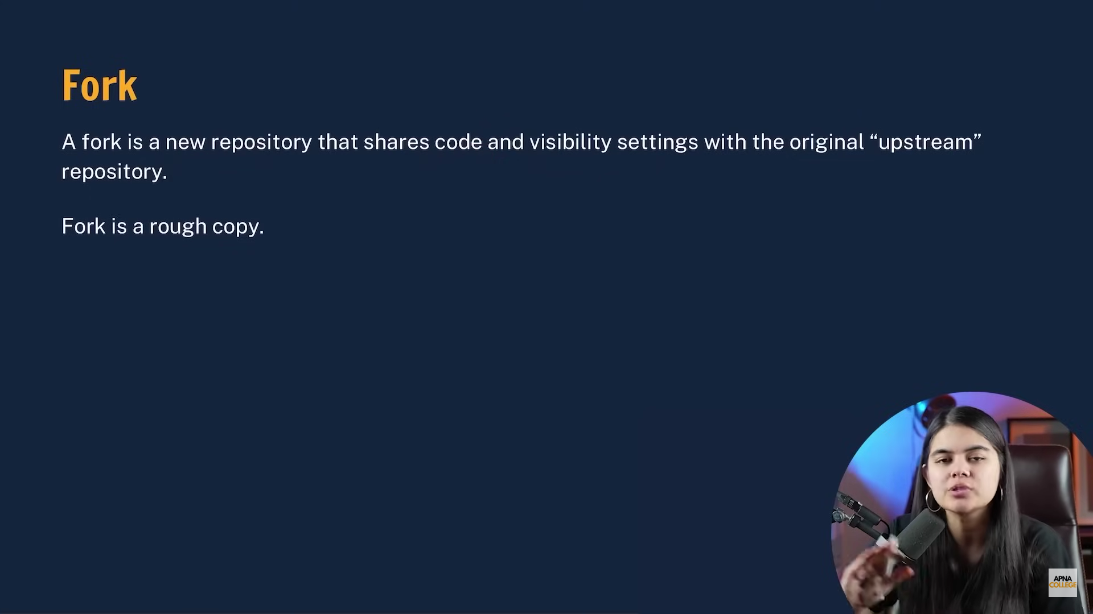

Fork can create a copy of other’s repository or work to our github account where we can mention changes in it.